Team Number 10
Project Title: Intelligent and Collaborative Autonomous Robots for Real-Time Applications
Report Date: 9/30/2024
Part one: Progress status as a team
All team members have detailed tasks listed on Teams Planner: YES
Please answer the following questions:
- Have you met as a team this past week? If yes, give date/time, and the members attended the meeting. If no, explain.
  - Yes, team met in person on 9/23 all members attending at 4:30

- Have you met with the sponsor as a team? If yes, give date/time, and the member attended the meeting. If no, explain.
  - Yes we have met with the team sponsor
    - John and Ian in the lab on 10/1 at 5:00 pm
    - David in the lab on 10/4 at 4:10 pm, Ian on teams call

- Describe verbally the tasks completed the past week and the challenges faced.
  - This week we were able to upload our code to the dog using WinSCP as a means of file transfer. After we were able to run our code using these frustrating camera as the source allowing us to see the live feed with our model running
  - A few required packages were needed to properly run the code on the dog as there are no automatic updates for this software
  - Current issue is that the live feed is very slow, making it impossible to use YOLOv8 effectively
- Describe the tasks to be completed the coming week.
  - For the coming week we are going to be creating a bash file to compile all the needed inputs into a single executable and testing that it works appropriately
  - The live model doesn’t appear to be accessing the onboard GPU causing an insane lag from the live feed. We are working on making this resource available in our code
  - We are going to also be having the our robot mobile as we run the YOLO model and eventually using functions to generate the dog’s movement

Copy the following table from the last week’s report (09/23)
 | # Tasks completed past week | # Tasks not completed | # Tasks for next week
David Uzan | 1 | 2 | 2
Ian Simmons | 2 | 0 | 2
John Sinfuego

Fill in the following table for this week: (09/30)
 | # Tasks completed past week | # Tasks not completed | # Tasks for next week
David Uzan | 2 | 0 | 1
Ian Simmons | 3 | 0 | 2
John Sinfuego

Part 2: Individual Progress Report (each member complete one form)
Name of the Member: Ian Simmons
Report Date: 9/30/2024
List the following:
- All tasks completed the week before the past week (completion date in parenthesis). This is copied from the last report, and if this report is the first one, skip.
- All tasks completed the past week (completion date in parenthesis)
- All tasks you are currently working on or planned for this coming week (completion date in parenthesis)
For each task you have completed before the past week:
- Week 5, Task 1 (9/23)
  - I was able to access the front facing camera on the dog and display the live feed from the onboard nano after updating the files on the dog directory. Having Internet made this possible

- Week 5, Task 2 (9/23)
  - We were able to update the different dependencies needed for the dog to run the camera feed over a local device.
For each task you have completed during the past week:
- Week 6, Task 1 (9/30)
  - This week I was able to download our model onto the dog using WinSCP as a file transfer method. This was the simplest way to have the files sent to the dog from a different OS
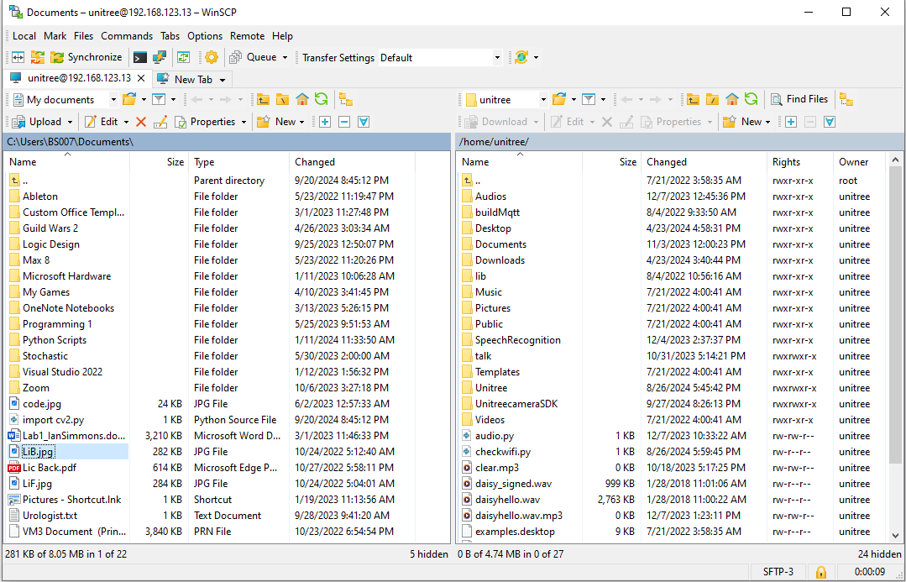

- Week 6, Task 2 (9/30)
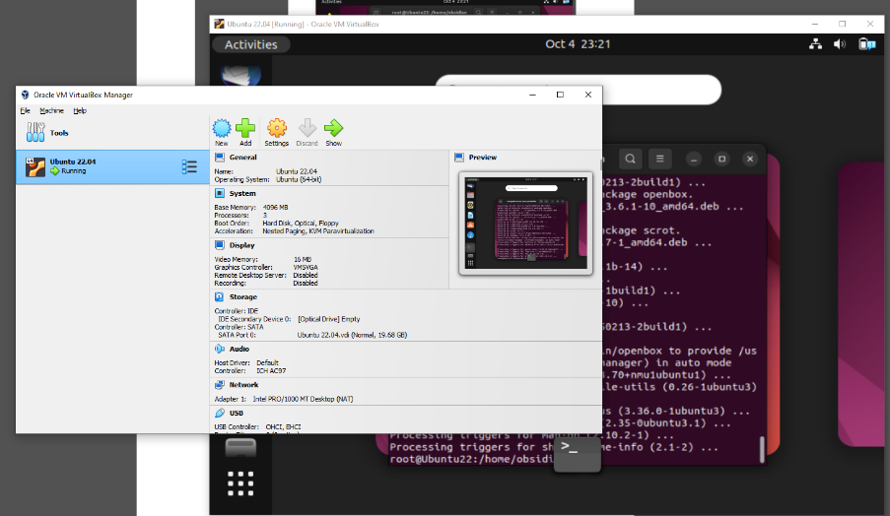
  - Using the Oracle VirtualBox program I was able to get a virtual instance of Ubuntu running on my computer for easier interaction with the devices onboard the dog
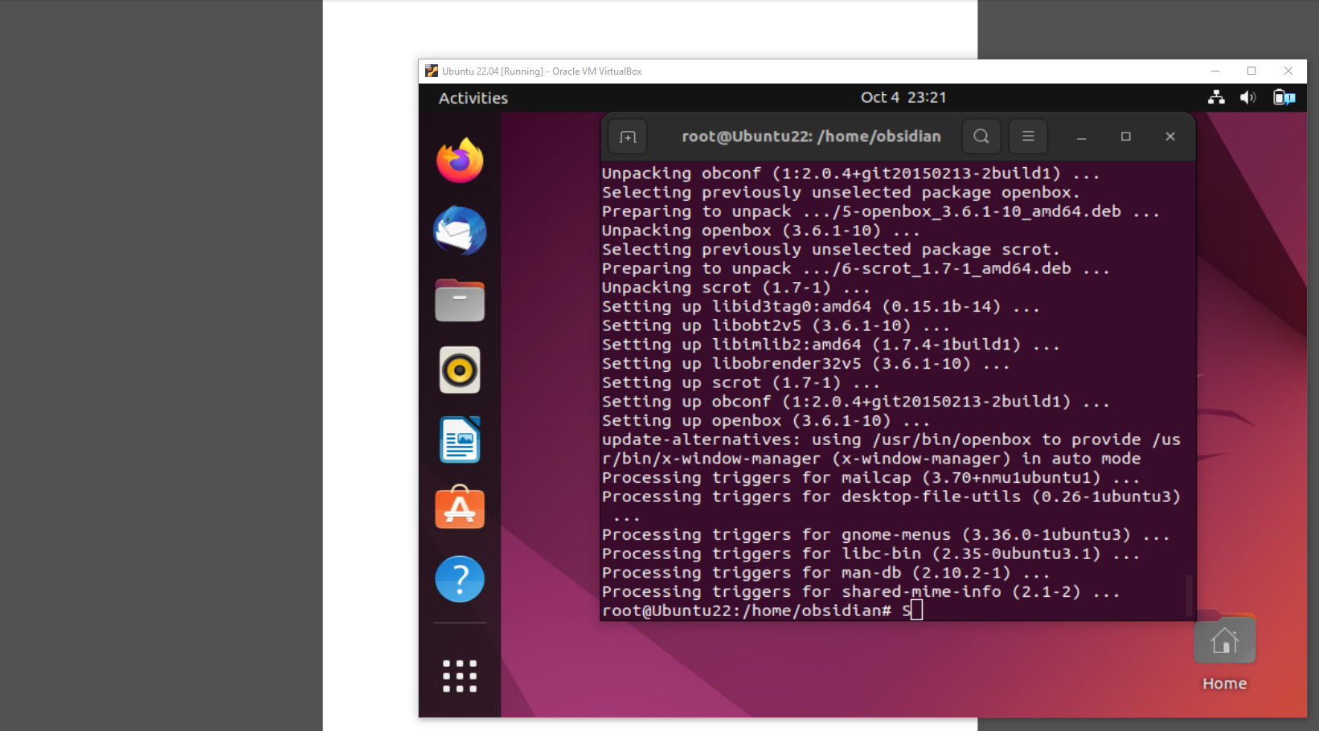
  - The necessary dependencies for YOLO to be ran on this virtual OS were also being installed (Python, pip, OpenCV, X11, GStreamer, Ultralytics, Conda)
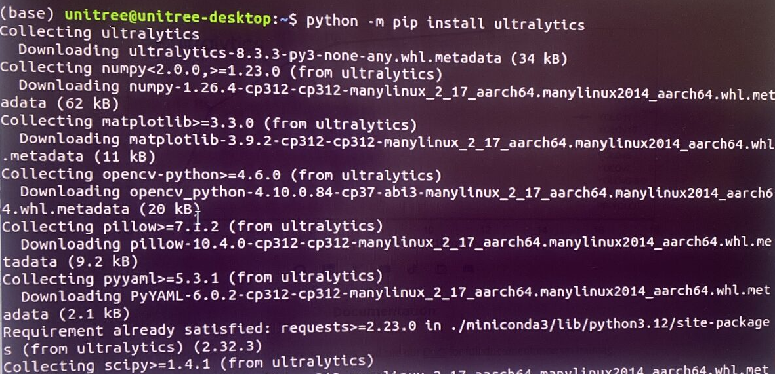

- Week 6, Task 3 (9/30)
  - My third task was to find a way to incorporate the YOLO model over the live feed from the dog.
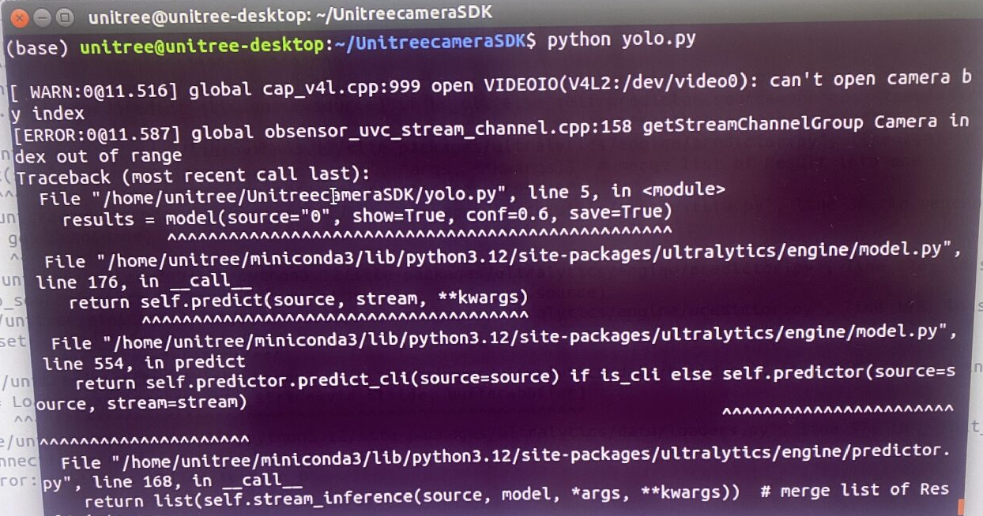
  - The issue was that we did not have an idea of what the model would consider the source for our camera.
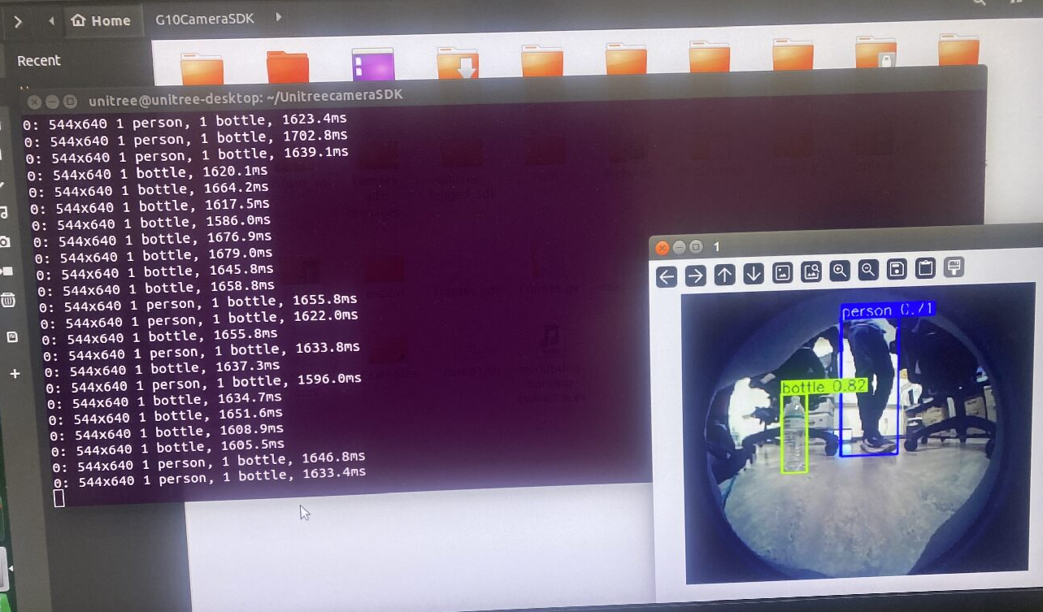
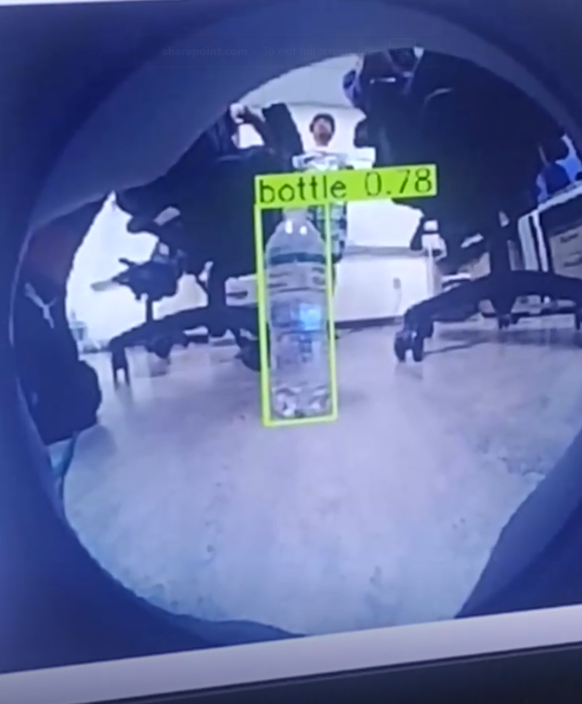
  - Through some trial and error figured out and the model was running over the live feed. We are able to see the stats and video feed running the model.

For each task you are currently working on or plan to work on in the next period:
- Week 7, Task 1 (10/7)
  - For next week my task is going to be accessing the GPU power for our YOLO model
  - Although we were able to get a live feed coming from the dog, the response time is too slow to be effective. It appears that the dog is only using the CPU power in the head as opposed to the GPU power of the main Raspberry Pi onboard the Unitree Go1
- Week 7, Task 2 (10/7)
  - If we are successful in accessing the GPU I will be able to run the model with very drastic improvement to the framerate. I will be documenting the improvements seen.

Part 2: Individual Progress Report (each member complete one form)
Name of the Member: David Uzan
Report Date: 9/30/24
List the following:
- All tasks completed the week before the past week (completion date in parenthesis). This is copied from the last report, and if this report is the first one, skip.
- All tasks completed the past week (completion date in parenthesis)
- All tasks you are currently working on or planned for this coming week (completion date in parenthesis)
For each task you have completed during the before the past week:
- Task number/name
Personal Week 4 (9-30-24) – Locate camera source directory in Uni-Go1

For each task you have completed during the past week:
- Task number/name
Personal Week 5 (9-30-24) - Add object detection python file to Uni-Go1
Personal Week 6 (9-30-24) - Run and display live tracking from robot

- Short description – these descriptions form the basis of the final project report
  - Implementation, testing, results
My groupmates made great progress in accessing the robot’s internal files by accessing the individual nodes when connected to the robot’s local network. The python file containing the detection model was brought over and run on the system with about 1400 ms to process a frame. I updated the YOLO model from version 8 to 11 and saw a slight reduction in the processing speed to about 1200 ms, but we are still researching optimization methods. We connected to the second node which is responsible for the front facing cameras and we made sure that the camera view was not distorted with the fisheye lense from before. The resulting live feed from the robot was very slow but showed promising signs as it could detect objects fairly confidently.
  - Brief and to point
The python file was inserted into the robot’s nanos and was updated to a better processing version. The results were slightly better than the previous version but were still enough to see live updates of the surroundings being identified correctly.

- Outcome of the task activity
  - How did the task advance your project?
We now can focus on optimization of the camera feed instead of finding root locations and implementing the detection model. We will soon begin the robot’s movement portion of the project and reach our goals.
  - Include screen shots, link to videos, plots, data tables, designs, figures, etc. as evidence of your work on the task
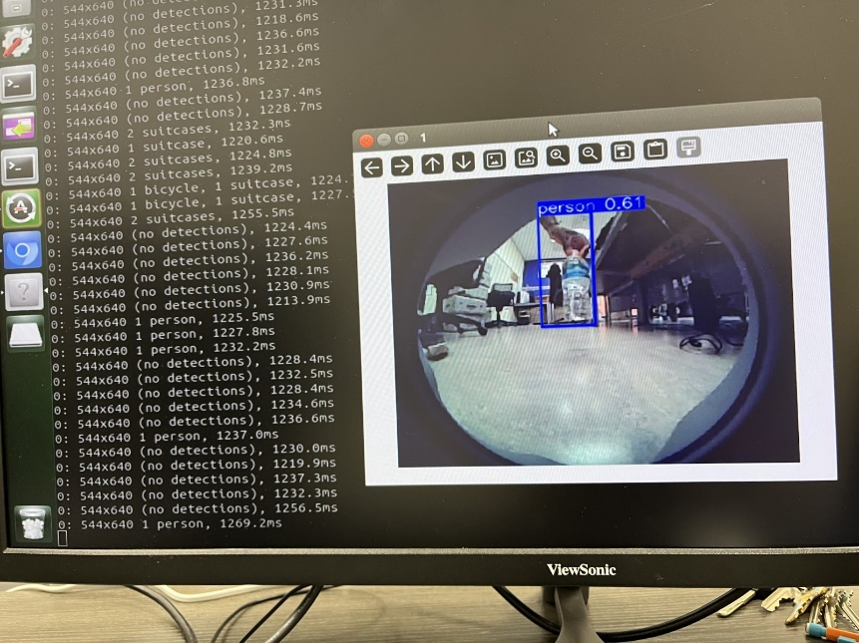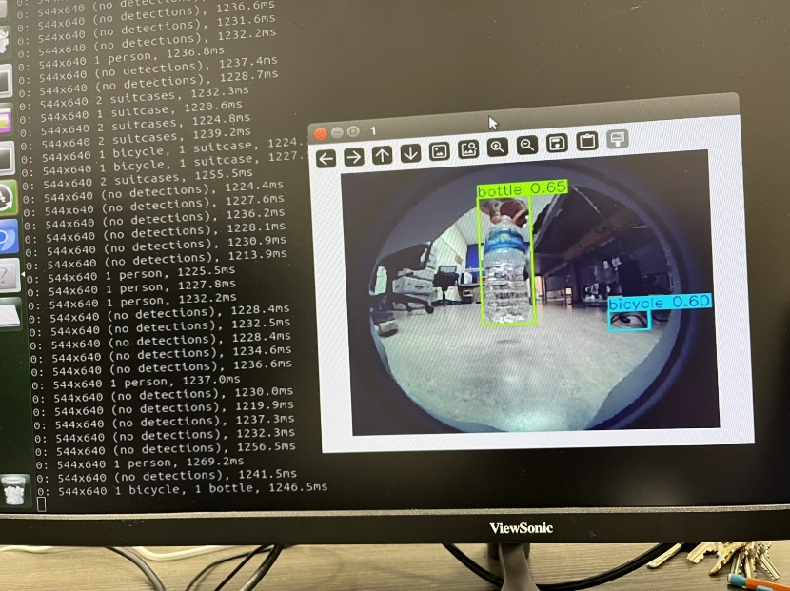
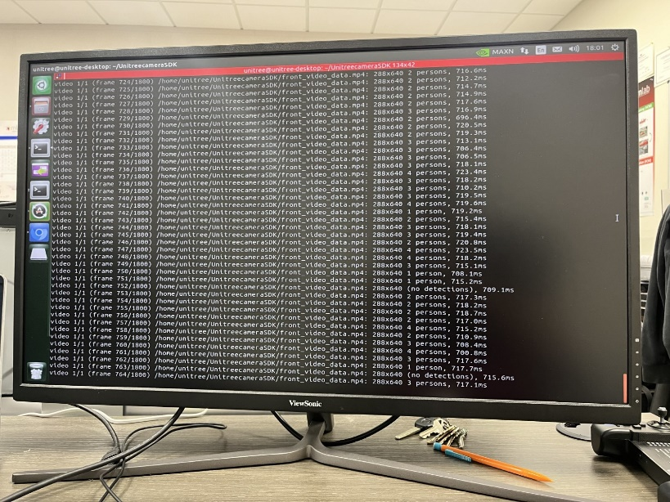
Running the code on a video to test if runtime is faster than live feed.

For each task you are currently working on or plan to work on in the next period:
- Task number/name
Personal Week 7 (10-7-24) - Create Batch file to kill camera processes and run python file on dog. Run on dog while in motion.

- Short description
  - Plans, resources needed, implementation, results
The batch file would be very simple to create, and it would be in our best interest to add a timer to give us enough time to properly prepare the dog to be moved around and not cause an issue. If we can safely use the model on the dog while it moves around, we will be able to move forward with optimization of the model using the external CPU we have set aside for the project.

  - Main challenges, reasons for any delay in completion
The current connection we have with the robot has its motors turned off and connected with multiple wires to observe and interact with the embedded operating system.

- Outcome of the task activity
  - Include screen shots, link to videos, plots, data tables, designs, figures, etc. as evidence of your work on the task
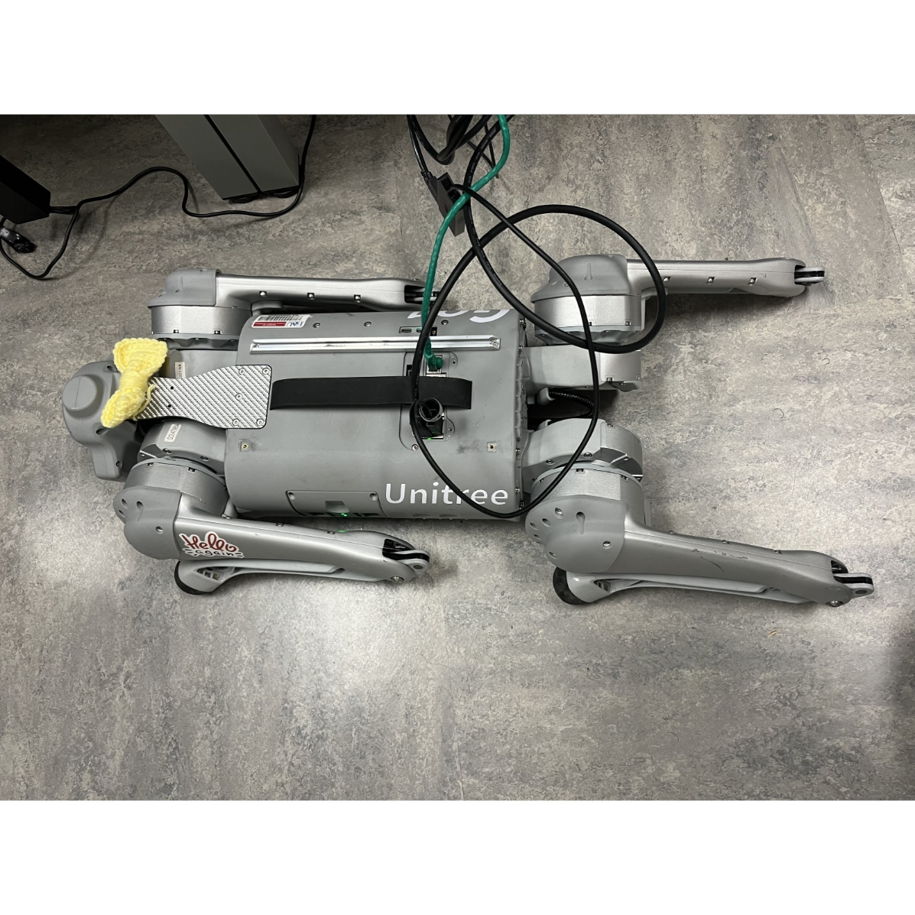
At our current point, we have ethernet, a mouse, and keyboard all connected to the dog.

Name of the Member: John Angelo Sinfuego
Report Date: 9/30/24

For each task you are currently working on or plan to work on in the next period:
- Task number/name
General Task 5 10-4-24- N/A

Personal Week 5 10-4-24- - Send commands to robot via powershell, create code to monitor performance
2. Short description
a. N/A

b. N/A solution to make the speed and run time faster.
- Outcome of the task activity

Name of the Member: John Angelo Sinfuego
Report Date: 9/30/24

For each task you are currently working on or plan to work on in the next period:
- Task number/name
General Task 5 9-30-24- Incorporate our model onto unitree, Run tests in order to access camera

Personal Week 5 9-30-24- - Kill nano1 camera process on dog in python, create a fuction so start new live feed oc camera
2. Short description
a. We made significant progress in this project. My team members and I managed to get the YOLOv8 repository running through the camera in uni-go1. This means we can get live feed with live object detection from Uni-Go1. We can then advance onto our next step involving Uni-Go1 and interacting with the object detection through YOLOv8.

b. For our challenges, the camera when run by YOLOv8 is running relatively slow and we are currently looking for a solution to make the speed and run time faster.
- Outcome of the task activity

